**A MINI PROJECT REPORT ON**

**“3AH E-COMMERCE SALES”**

**SUBMITTED TOWARDS THE FULFILLMENT OF THE REQUIREMENTS OF**

**BACHELOR OF ENGINEERING (B. Tech.)**

**Academic Year: 2023-24**

**Submitted By**

**BTCOC221 Atharva Kadam**

**BTCOC224 Abhishek Utage**

**BTCOC226 Anush Shetty**

**BTCOC230 Harsh Gupta**

**Under The Guidance of**

**Prof. Chetan Chauhan**



**DEPARTMENT OF COMPUTER ENGINEERING,**

**PIMPRI CHINCHWAD COLLEGE OF ENGINEERING**

**SECTOR 26, NIGDI, PRADHIKARAN**



PIMPRI CHINCHWAD COLLEGE OF ENGINEERING

DEPARTMENT OF COMPUTER ENGINEERING

**CERTIFICATE**

This is to certify that, the project entitled

**3AH E-COMMERCE SALES**

is successfully carried out as a mini project successfully submitted by following students of “PCET's Pimpri Chinchwad College of Engineering, Nigdi, Pune-44**”.**

**Under the guidance of Prof. Chetan Chauhan**

In the fulfilment of the requirements for the B. Tech. (Computer Engineering)

**BTCOC221 Atharva Kadam**

**BTCOC224 Abhishek Utage**

**BTCOC226 Anush Shetty**

**BTCOC230 Harsh Gupta**

**Prof. Chetan Chauhan Prof Dr.K .Rajeswari**

**Guide Head,**

**Department of Computer Engineering Department of computer Engineering**

**Abstract**

E-COMMERCE, as one of the world's leading retailers, continually redefines the landscape of the retail industry by harnessing the power of data and analytics to drive sales growth and customer satisfaction. This abstract provides a brief overview of how E-COMMERCE has transformed the retail sector through its extensive data analytics and sales insights. In the ever-evolving landscape of the retail industry, the role of Business Intelligence (BI) has become increasingly vital. E-COMMERCE, one of the world's largest retailers, has leveraged BI to gain valuable insights into its sales operations, customer behaviors, and market trends. This abstract provides a glimpse into how E-COMMERCE has harnessed the power of Business Intelligence to drive sales growth, enhance customer experiences, and stay competitive in an ever-changing market.

E-COMMERCE's approach to gaining sales insights is a testament to the importance of data in modern retail operations. Through the aggregation and analysis of vast amounts of transactional, customer, and market data, E-COMMERCE has established a robust data-driven ecosystem. This ecosystem provides a comprehensive view of its sales, customer behaviors, and emerging market trends.

In a highly competitive market, E-COMMERCE's reliance on Business Intelligence empowers the company to adapt quickly to changing market conditions. Through real-time dashboards and reporting tools, executives and decision-makers are equipped with the data necessary to make informed choices and capitalize on emerging opportunities. This agility enables E-COMMERCE to not only maintain its position as a retail giant but also expand its market presence.

In the dynamic retail market, E-COMMERCE's reliance on data and analytics gives it a competitive edge by allowing rapid adaptation to market changes.This agility is a cornerstone of E-COMMERCE's continued success and expansion in the highly competitive retail landscape.

**INDEX**

| **Chapter** | **Contents** | | **Page No.** |
| --- | --- | --- | --- |
| 1. |  | Introduction |  |
|  | *a.* | Problem Statement | 5 |
|  | b. | Project Objectives | 6 |
|  | *c.* | Motivation | 7 |
|  | *d.* | Literature Survey/ Requirement Analysis | 7 |
| 2. |  | Project Design |  |
|  | *a.* | H/W , S/W , resources, requirements & their detail explanation | 10 |
|  | *b.* | Block diagram with explanation of each module | 13 |
| 3. |  | Results & Discussion with comparative analysis |  |
|  | *a.* | Comparative analysis of all existing models including new model. |  |
|  | *b.* | Screenshots of Dashboard: Explain Dashboard components | 14 |
| 4. |  | Conclusion | 17 |
| 5. |  | References | 18 |

**Figure Table**

|  |  |  |
| --- | --- | --- |
| **Fig. No.** | **Context** | **Page No** |
| 1 | Block Diagram | 13 |
| 2 | Dashboard for All Years | 14 |
| 3 | Dashboard for Year 2012 | 14 |
| 4 | Dashboard for Year 2014 | 15 |

1. **INTRODUCTION**

E-COMMERCE's commitment to gaining comprehensive sales insights through data analysis is not merely a competitive advantage but a necessity in today's dynamic marketplace. The retail industry has evolved rapidly, and so has consumer behavior, with shoppers expecting seamless experiences and personalized interactions. In response to these shifting dynamics, E-COMMERCE has embraced cutting-edge data analytics and business intelligence to gain a deeper understanding of its operations, customers, and market trends.

Central to E-COMMERCE's approach is the meticulous collection and analysis of a wide array of data sources, encompassing sales transactions, customer demographics, online interactions, and real-time market intelligence. These data sources are integrated into a sophisticated ecosystem that provides a holistic view of the business, enabling E-COMMERCE to respond rapidly and effectively to market changes and customer preferences.

Beyond these internal operations, E-COMMERCE extends its data-driven strategies to elevate customer experiences. Through personalized recommendations, targeted marketing campaigns, and a seamless shopping journey, the company ensures that it aligns with individual customer preferences. This approach results in increased sales conversion rates and fosters customer loyalty.

In a fiercely competitive retail environment, E-COMMERCE's reliance on data analytics and business intelligence positions it as an agile and proactive leader, equipped to navigate the ever-shifting landscape. Real-time dashboards, intuitive reporting tools, and data visualization techniques enable executives and decision-makers to act on insights promptly, making informed decisions that drive growth and keep the company at the forefront of the industry.

In this exploration, we will delve into the specific machine learning applications that E-COMMERCE has employed to sharpen its competitive edge. This includes demand forecasting, inventory optimization, pricing strategies, and personalized marketing initiatives. Each application showcases how machine learning augments E-COMMERCE's ability to make data-informed decisions, leading to increased sales, reduced operational costs, and a more seamless shopping experience for its customers.

Moreover, we will unveil how E-COMMERCE employs machine learning for data visualization and reporting, ensuring that the insights generated are easily accessible to decision-makers across the organization. Interactive dashboards, real-time analytics, and intuitive visualization tools are key components of this strategy, bridging the gap between data analysis and strategic implementation.

**1.1 Problem Statement**

The problem statement for E-COMMERCE's data sales insights with respect to machine learning algorithms revolves around the need to harness the vast amounts of data generated by the retail giant for strategic advantage. E-COMMERCE faces the challenge of optimizing its operations, improving customer experiences, and driving sales growth in an increasingly competitive retail landscape. Machine learning algorithms are crucial in this context as they can unlock hidden patterns, trends, and customer behaviors within the data. The specific issues include accurate demand forecasting, dynamic inventory management, personalized pricing strategies, and targeted marketing efforts. E-COMMERCE seeks to leverage machine learning to transform this data into actionable insights that enhance product availability, pricing precision, and customer satisfaction. Additionally, the challenge lies in creating a scalable and adaptable system that allows for real-time data analysis and decision-making across its vast network of stores, both physical and digital. The ultimate goal is to remain at the forefront of the retail industry by using machine learning to continually refine and optimize its operations and customer interactions.

**1.2 Project Objectives**

Improve operational efficiency: This includes identifying top-performing and underperforming stores and departments, understanding customer buying patterns and trends, optimizing inventory levels and product placement, reducing waste and spoilage, and improving supply chain management.

Increase sales and profitability: This includes identifying new sales opportunities, developing targeted marketing campaigns, increasing customer engagement and loyalty, launching new products and services, and pricing products competitively.

In addition to these general objectives, E-COMMERCE sales insights can also be used to achieve specific business goals, such as:

* Increasing sales of a particular product category or brand
* Expanding into new markets or channels
* Improving customer satisfaction
* Reducing costs
* Launching new products or services
* Optimizing pricing

**1.3 Motivation**

E-COMMERCE's motivation for data insights lies in its pursuit of maintaining a competitive edge in the retail sector, optimizing operations, and enhancing the customer experience. By leveraging data, E-COMMERCE aims to drive sales growth, reduce operational costs, and make informed, data-driven decisions at all organizational levels. The company is motivated to stay at the forefront of retail innovation by embracing emerging technologies such as machine learning and artificial intelligence. It seeks to adapt to changing market conditions, bridge the online-offline retail gap, and contribute to sustainability efforts through efficient resource management. In summary, E-COMMERCE's motivation for data insights revolves around improving its overall performance, fostering innovation, and remaining agile in an ever-evolving retail landscape.

**1.4 Literature Survey/ Requirements Analysis**

[1] E-COMMERCE's Sales Data Analysis using Machine learning:

This study analyzes data gathered from a retail establishment and makes predictions about future management strategies for the establishment. The impact of various order of Events like the weather, holidays, and so forth can genuinely alter the condition of many sections such that it also explores these factors and looks at how they affect sales.

[2] D-MART SALES PREDICTION:

The fundamentals of machine learning and the related data processing and modeling methods have been discussed in this work, followed by their application to the challenge of predicting sales in several D Mart shopping centers. Following implementation, the prediction results display the relationships between the various attributes taken into The location with the best sales was medium-sized, suggesting that additional shopping areas could adopt similar strategy patterns that will increase sales. To construct this sales prediction, a number of example parameters and other variables can be used more successfully and innovative.

[3] Sales Prediction System Using Machine Learning:

By using approaches like Clustering Models and measurements for sales forecasts, the goal of this article is to obtain accurate findings for predicting future sales or demands of a corporation. The potential of the algorithmic techniques is appraised and utilized appropriately in subsequent study.

**Requirements Analysis:**

[1] Data Sources Identification: Understanding where E-COMMERCE's sales data is generated and collected, including point-of-sale systems, online transactions, and third-party sources.

[2] Data Types: Determining the types of data to be analyzed, such as sales transactions, customer demographics, product information, and market data.

[3] Data Volume and Velocity: Assessing the volume of data generated and the speed at which it's generated, as E-COMMERCE deals with vast quantities of data in real-time

[4] Data Quality: Identifying data quality requirements to ensure accurate and reliable analysis, including data cleansing and normalization.

[5] Security and Compliance: Addressing security and compliance requirements, especially in handling sensitive customer information and adhering to data protection regulations.

[6] Business Objectives: Collaborating with E-COMMERCE's stakeholders to understand their specific business objectives, such as increasing sales, reducing costs, or improving customer satisfaction.

[7] KPIs and Metrics: Defining key performance indicators (KPIs) and metrics to measure the success of the sales insights program, such as sales conversion rates, customer lifetime value, and inventory turnover.

[8] User Requirements: Gathering input from end-users, including executives, data analysts, and decision-makers, to understand their information needs and preferred formats for data presentation.

[9] Scalability: Ensuring that the data analytics infrastructure can scale to handle increasing data volumes and user demands as E-COMMERCE grows

[10] Training and Skill Development: Recognizing the need for training and skill development among employees to effectively utilize the data insights generated.

**2. PROJECT DESIGN**

**2.1 H/W, S/W, resources, requirements & their detail explanation**

1. **Hardware (H/W) Requirements:**

* **Processor:** A multi-core processor is recommended, such as an Intel Core i5 or i7, or an AMD Ryzen processor.
* **RAM:** At least 8GB of RAM is typically the minimum for basic data analysis and visualization tasks.
* **Storage:** An SSD (Solid State Drive) is highly recommended for faster data access and application loading.
* **Graphics Card (GPU):** For basic data analysis and visualization, integrated graphics on the CPU is usually sufficient.
* **Network:** A standard Ethernet or Wi-Fi connection is typically sufficient for accessing E-COMMERCE sales data, as long as your internet connection is stable and provides reasonable bandwidth.
* **Monitor:** The choice of monitor largely depends on your preference and needs.
* **Software(S/W) Requirements:**
* **Power BI Desktop:** Power BI Desktop is a Windows application used for creating and designing data visualizations and reports. You can download it for free from the Microsoft Power BI website.
* **Power BI Service:** Power BI Service is the cloud-based service provided by Microsoft for sharing, collaborating, and publishing Power BI reports and dashboards. It allows you to publish your reports and share them with others online.
* **Data Sources:** You will need access to the relevant data sources, which may include E-COMMERCE's sales data. The specific data sources and how you connect to them can vary. Power BI supports a wide range of data sources, including databases, cloud services, Excel files, and more. Ensure you have access to the necessary data or data connectors.

**Resources**

* **E-COMMERCE Sales Data:** E-COMMERCE may provide access to their sales data through APIs or data sharing agreements. Contact E-COMMERCE's data services or IT department to inquire about data access.
* **Historical Sales Data:** You can use historical sales data to train machine learning models. This data may be available from E-COMMERCE or can be collected over time.
* **Public Datasets:** Look for publicly available retail sales datasets that you can use for training purposes. Websites like Kaggle and UCI Machine Learning Repository offer various datasets.
* **Machine Learning Models**: Python and R ,AutoML Tools , Custom Models
* **Documentation:** Check if E-COMMERCE provides documentation or guidelines on their data access and any specific data format.

**Requirements and their detailed Explanation:**

**Define Objectives:** Clearly state the objectives of your data insights project. What do you want to achieve with E-COMMERCE's data? Are you looking for sales trends, customer behaviour insights, inventory optimization, or something else?

**Stakeholder Identification:** Identify the key stakeholders and their roles in the project. This can include business analysts, data scientists, IT professionals, and decision-makers.

**Data Sources:** Determine the specific data sources you will use. Are you working with point-of-sale (POS) data, online sales data, inventory data, or a combination of these? Identify how you can access and integrate these data sources.

**Data Collection and Integration:** Specify the methods and tools for collecting, cleansing, and integrating data from various sources. Ensure data quality and consistency.

**Data Processing and Storage:** Define the data processing requirements, such as data transformation, aggregation, and storage. Consider the technology stack for handling large datasets efficiently.

**Data Analysis:** Describe the types of analyses you plan to perform. Will you be using descriptive, diagnostic, predictive, or prescriptive analytics? What metrics and KPIs are relevant to your objectives?

**Machine Learning Models:** If machine learning is a part of your project, specify the types of models you plan to use and the data required for training and testing.

**Data Visualization and Reporting:** Define how you will present insights. Are you using Power BI, Tableau, custom dashboards, or other tools? Identify the key performance indicators (KPIs) that will be displayed.

**User Requirements:** Consider the needs of end users who will interact with the insights. What kind of reports, dashboards, or interactivity do they require?

**Project Timeline:** Create a timeline with milestones and deadlines to manage the project effectively.

**Dataset Design:**

**Order ID (Alphanumeric):** A unique identifier for each sales order.

**Order Date (Date and Time):** The date and time when the order was placed.

**Ship Date (Date and Time):** The date and time when the order was shipped.

**Customer Name (Text):** The name of the customer who placed the order.

**City (Text):** The city where the customer is located**.**

**State (Text):** The state where the customer is located.

**Category (Categorical):** The category of the product (e.g., electronics, clothing, groceries).

**Product Name (Text):** The name of the product purchased.

**Sales Quantity (Numeric):** The quantity of the product sold in the order.

**Profit (Numeric):** The profit earned from the sale of the product.

**Delivery Date (Date and Time):** The date and time when the

**Time (Time):** The time it took for the order to be processed and delivered order was delivered to the customer.

**Dataset Structure:** Each row of the dataset represents a single sales order with information on order details, customer, product, and order processing. You may have thousands or even millions of rows, each corresponding to a unique sales transaction.

**Data Source:** The data source for this dataset could come from E-COMMERCE's sales records, which might be obtained through data access agreements or APIs if available.

**Data Quality:** Ensure data quality by addressing missing values, duplicates, and inconsistencies in the dataset**.**

**Data Integration:** You may need to integrate data from multiple sources within E-COMMERCE's systems to create a comprehensive

**2.3 Block diagram with Methodology:**

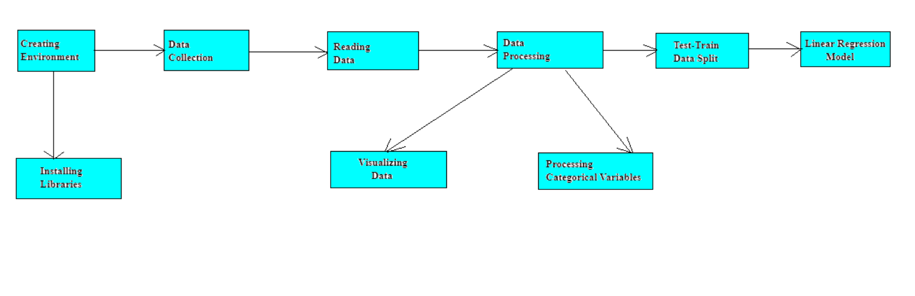

**Figure 1. Block Diagram**

This image shows the steps involved in creating a project. The steps are: Creating Environment: This involves setting up the necessary software and hardware environment for the project. Installing Libraries: This involves installing any necessary libraries or packages that will be needed for the project. Data Collection: This involves collecting the data that will be used for the project. Reading Data: This involves reading the collected data into the project environment. Visualizing Data: This involves creating visualizations of the data to explore it and identify patterns and trends. Data Processing: This involves cleaning and preparing the data for analysis. Processing Categorical Variables: This involves converting categorical variables into numerical variables so that they can be used in machine learning models. Test-Train Data Split: This involves splitting the data into two sets: a training set and a test set. The training set is used to train the machine learning model, and the test set is used to evaluate the performance of the trained model. Linear Regression Model: This involves training a linear regression model on the training set. Model Evaluation: This involves evaluating the performance of the trained model on the test set.

**3. Results & Discussion with comparative analysis**

**3.1 Screenshots including GUI and Dashboard: Explain Dashboard components**

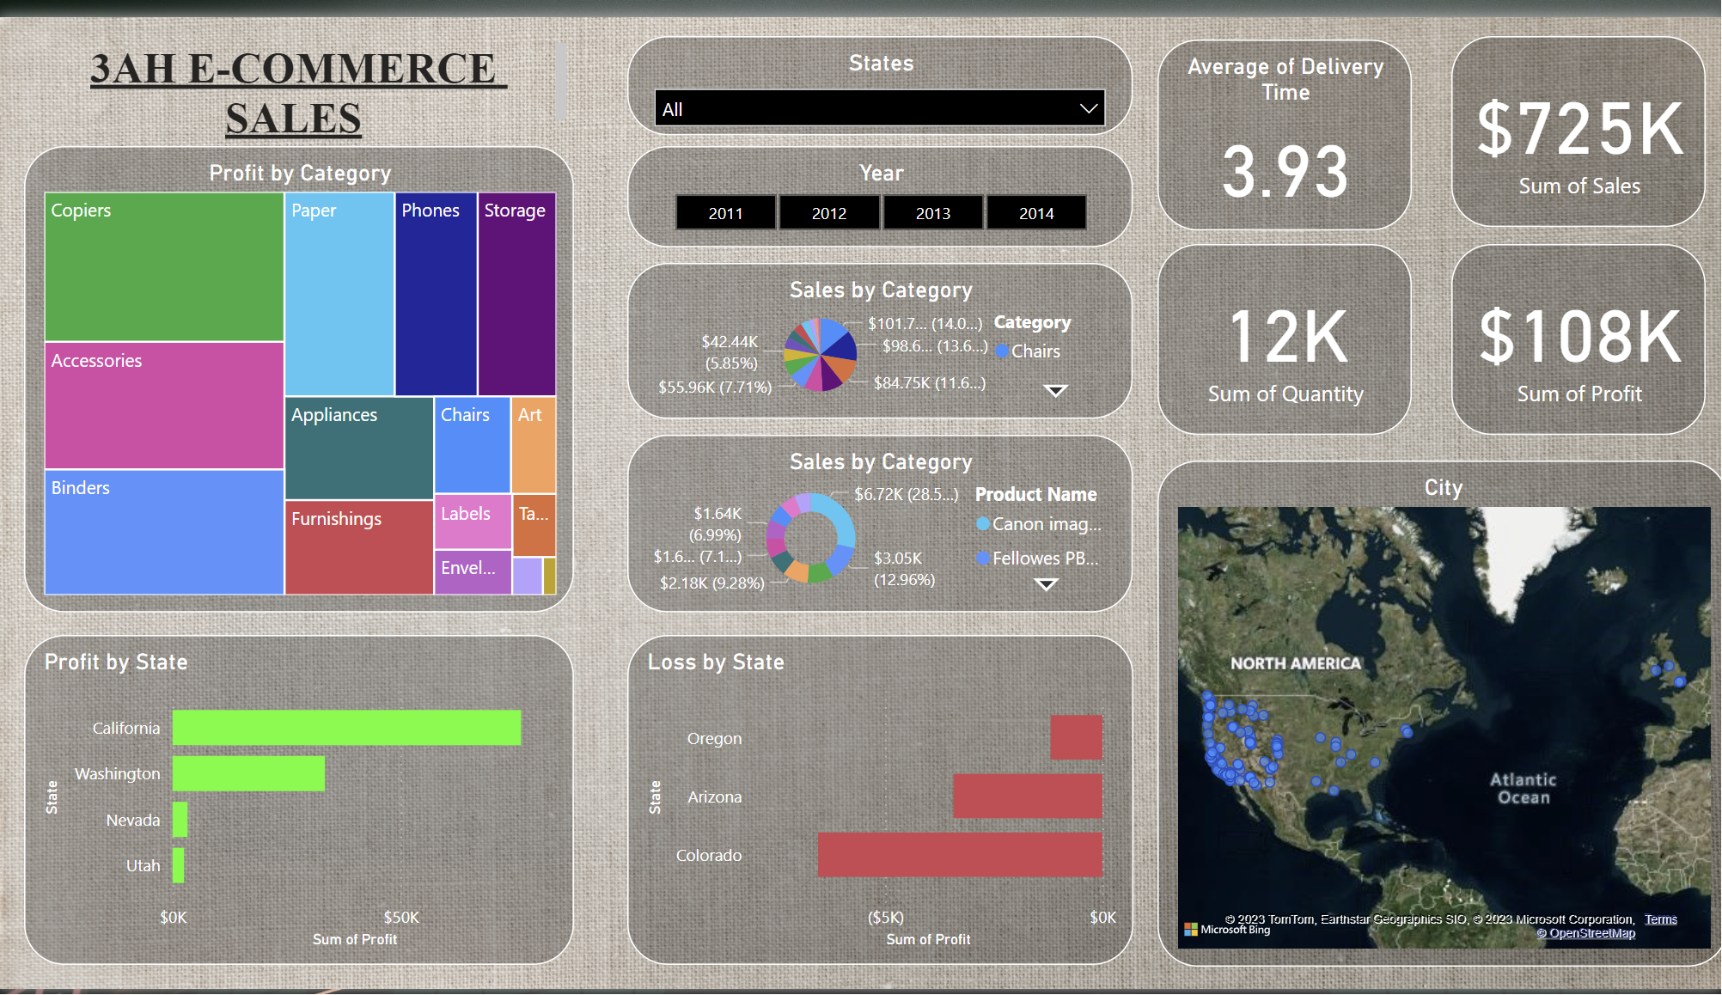

**Figure 2. Dashboard:** It represents the dashboard for average of all 5 years

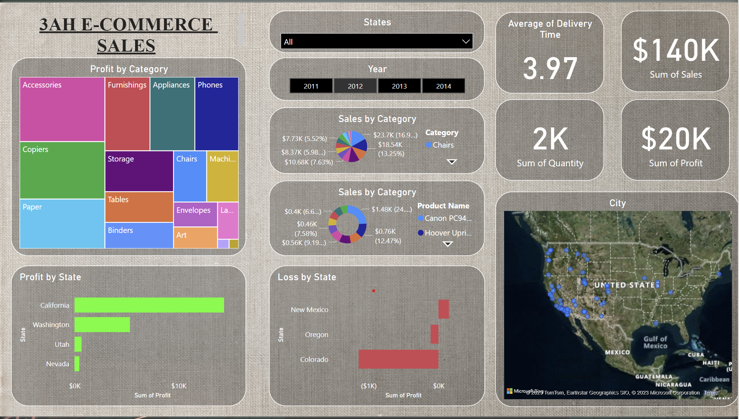

**Figure 3. Dashboard for Year 2012:** It represents the information about the year 2012

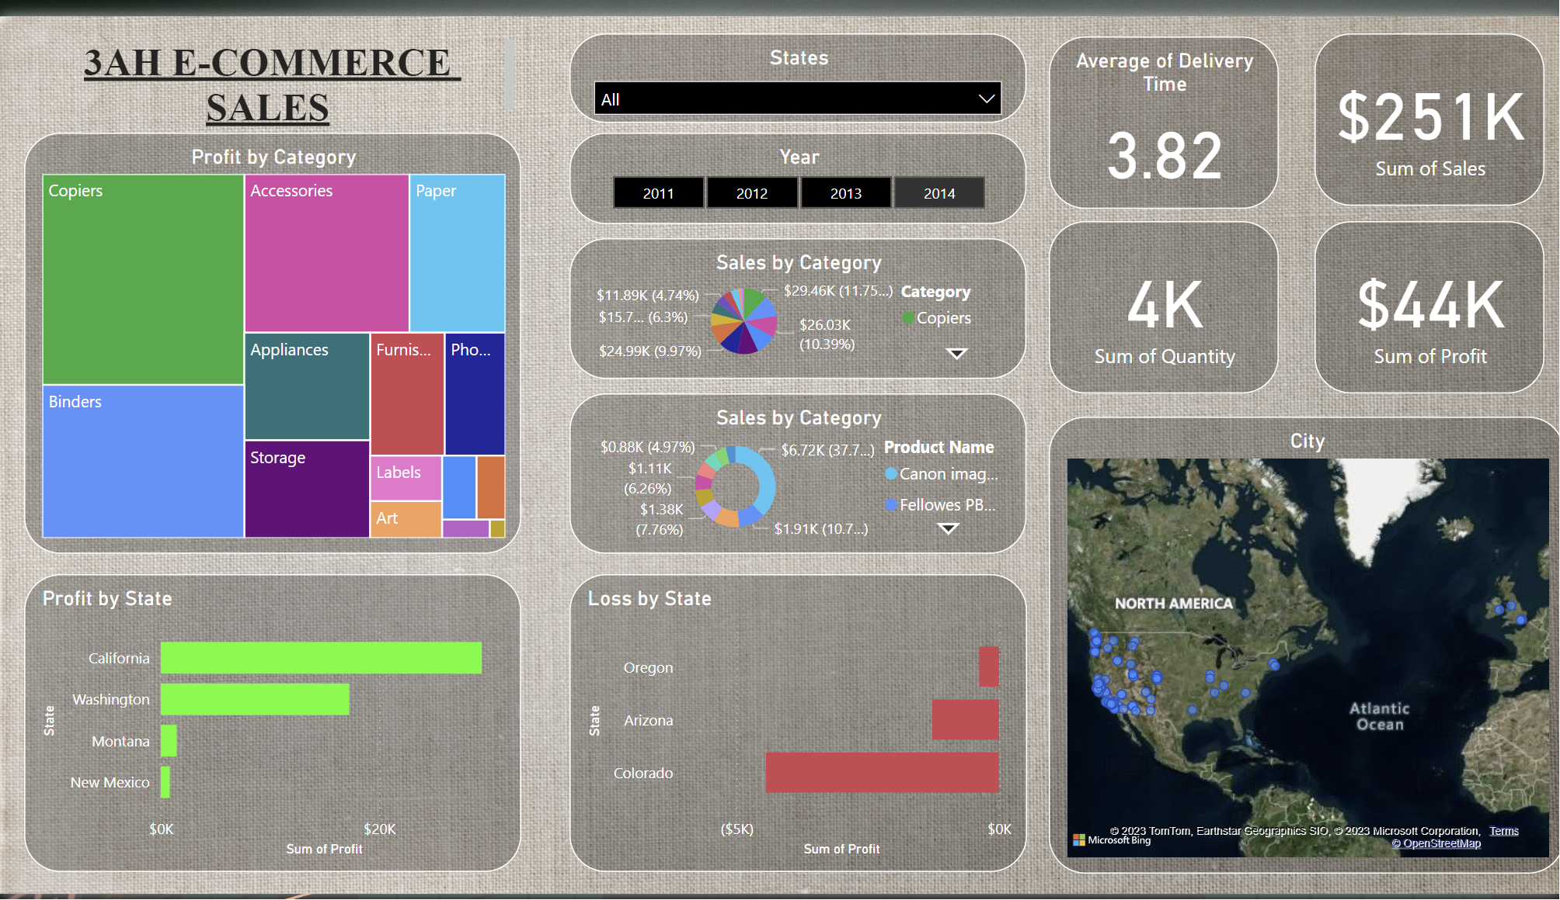

**Figure 4. Dashboard for Year 2014:** It represents the information about the year 2014

Explaining the components of a dashboard involves breaking down the various elements that make up the user interface and functionality of the dashboard.

[1] **Title and Header:** Begin by highlighting the title and header, which provide context and branding. The title should clearly convey the purpose of the dashboard here title is **E-COMMERCE sales insights**, while the header often contains important navigation elements and company logos.

[2] **Filters and Slicers:** Year/Month Selector: Allow users to select the year and month to analyse.

[3] **Location Selector:** If sales data is available for multiple locations, a drop-down or slicer to filter by location can be used.

[4] **Model Filter:** A filter for selecting specific models or categories.

[5] **Key Performance Indicators (KPIs):**

**Sum of Sales:**

**Sum of Profit:**

**Sum of Quantity:**

**Avg time of delivery:**

[6] **Geographic Analysis:** Map Visual: Display a map with pins or bubbles to represent sales locations. The size or colour of the pins can indicate sales volume, and tooltips can provide additional information.

[7] **Widgets and Visualizations:** Emphasize the core of the dashboard, which consists of widgets and visualizations. Widgets can include charts, graphs, tables, maps, and other visual elements that present data in a user-friendly and understandable format.

[8] **User Interactions:** Describe how users can interact with the dashboard, including drill-down options, mouse-over tooltips, and other features that enable deeper exploration of the data.

**4. CONCLUSION**

In conclusion, E-COMMERCE's pursuit of sales insights represents a remarkable journey in the retail industry. By harnessing the power of data analytics, business intelligence, and machine learning algorithms, E-COMMERCE has transformed the way it operates, serves its customers, and stays competitive in an ever-evolving marketplace.

Machine learning algorithms have played a pivotal role in this transformation. From demand forecasting and inventory optimization to pricing strategies and personalized marketing, these algorithms have enabled E-COMMERCE to make data-driven decisions with unparalleled precision. The result has been increased sales, reduced operational costs, and a more seamless shopping experience for customers.

Furthermore, the introduction of well-designed dashboards has provided stakeholders at all levels of the organization with a user-friendly interface for accessing and understanding these valuable insights. Real-time data visualization and interactive reporting have bridged the gap between data analysis and strategic implementation, enabling E-COMMERCE to act swiftly and effectively in response to emerging opportunities and challenges.

**5. REFERENCES**

a. R.C Patil, Asmita Desai , Pranita Jadhav, Shivani Shirole 2022. Sales Data Analysis Using Power BI(pp. 529-536).

b. Monika Jain, Priyanshi Raje, Vikrant Chole, F.F., 2021.Sales Analysis and Prediction Dashboard Using Power BI, 4(1), pp.51-61.

c. Kusonkhum, Rakhi Wajgi, Kiran Singh, N., Aksorn, P. and Chaitongrat, T., 2022. Data Analysis and Visualization of Sales Data Vol, 13(1).

d. Eisler, C. and Holmes, M., 2021. Data Analysis and Visualization of Sales Data. In ICPRAM (pp. 586- 593).

e. Li, S., Jiang, B., Liang, S., Peng, J., Liang, H., Han, J., Yin, X., Yao, Y., Zhang, X., Cheng, J. and Zhao, X.

f. 2022. Data Analysis for the Development of a Power BI Solution for Sales, 15(1), pp.1784-1816.

g. Fleni Stroulia, Isaac Matichuk, Fabio Rocha, Ken Baver, “Interactive Exploration of collaboration software development data,” in IEEE International Conference on Software Maintenance (ICSM), 2013.

h. Alaskar, T., & Efthimios, P. (2015). Business Intelligence Capabilities and Implementation Strategies. International Journal of Global Business, Vol. 8 (1), pp. 34- 45.

i. Delen, D., Sharda, R. & Turban, E. 2014. Business Intelligence: A ManagerialPerspective on Analytics. 3rd edition. England: Pearson Education Limited.